1. What is a Network?
A network is a group of devices connected together to exchange data.
Examples:
- Laptop ↔ Mobile
- Laptop ↔ Printer
- Laptop ↔ Internet Server
When two or more devices communicate, they form a network.

LAN (Local Area Network)
A network within a small geographical area.
Examples:
- Home Wi-Fi
- College Lab
- Office Network
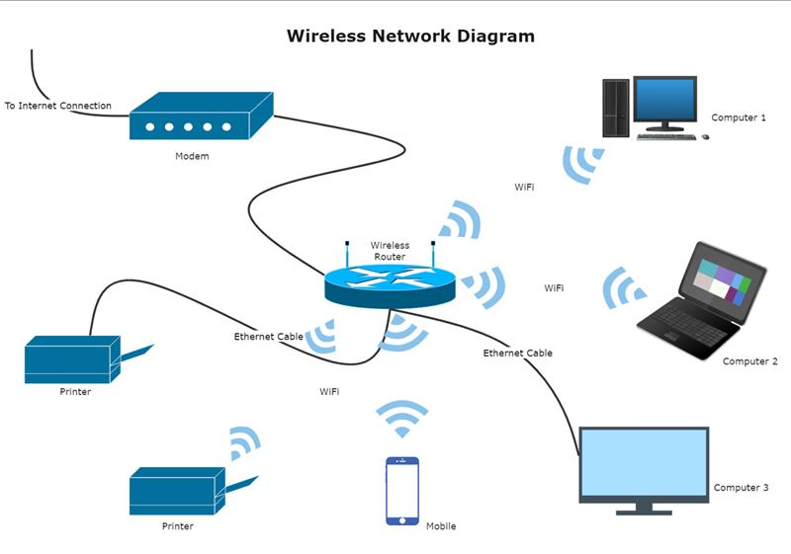
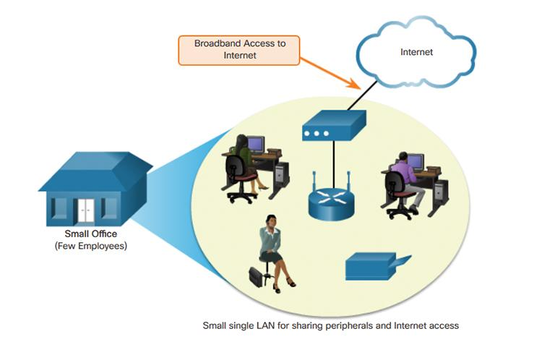
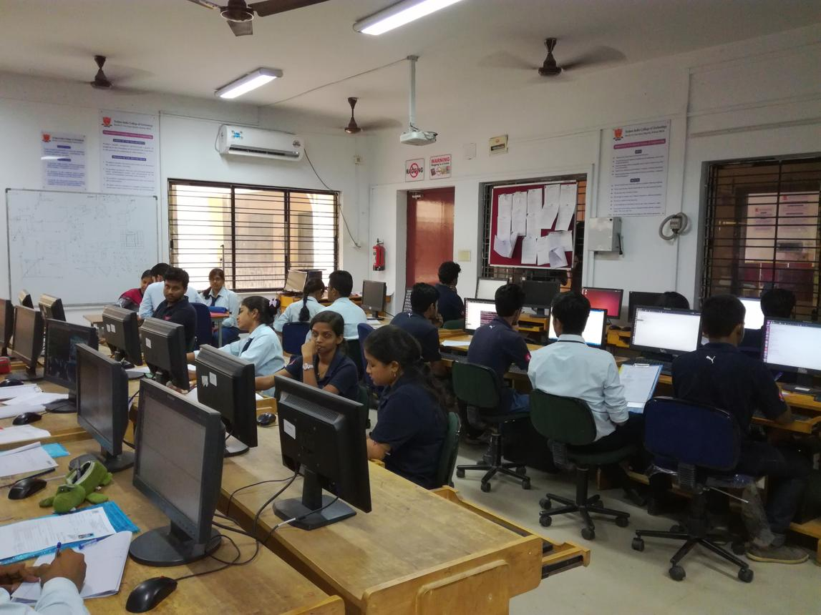
4

Characteristics
- Small area
- High speed
- Privately managed
- Low latency
Example:
Laptop ----\
Phone ------ Router ---- Internet
TV --------/
All devices connected to the same Wi-Fi router form a LAN.

MAN (Metropolitan Area Network)
Connects multiple LANs across a city.
Example:
A bank has branches across Udaipur.
Branch A LAN
|
|
Branch B LAN
|
|
Branch C LAN
All branches are connected together.

Characteristics
- Covers a city
- Faster than WAN
- Larger than LAN

WAN (Wide Area Network)
Connects networks over very large distances.
Example:
The Internet.
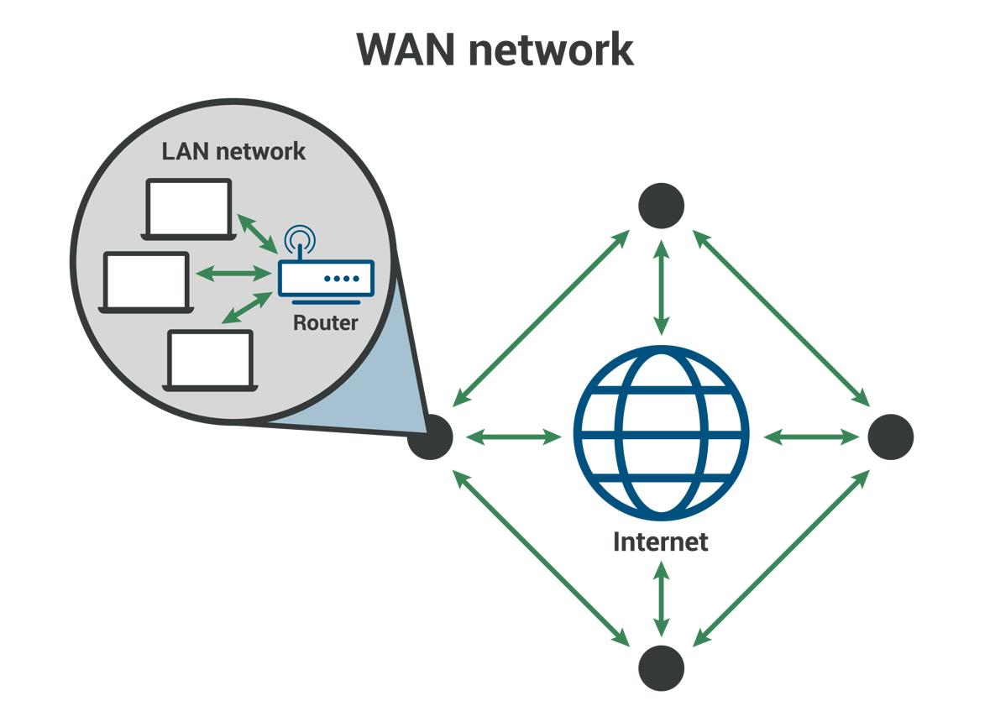
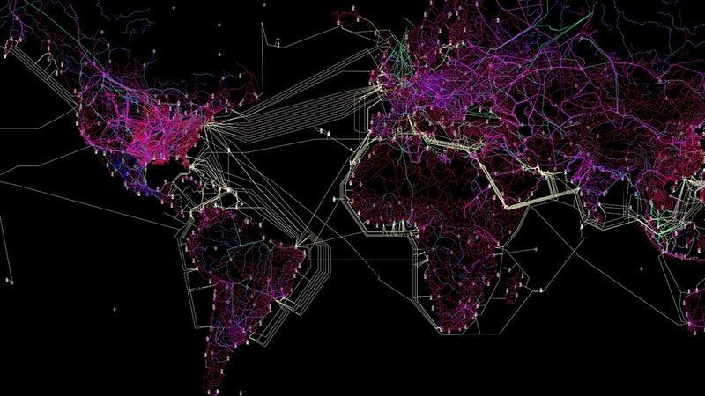
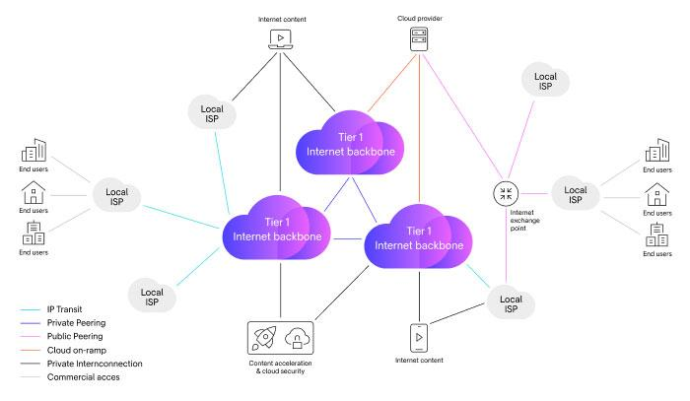
6

Characteristics
- Worldwide coverage
- Uses public and private networks
- Higher latency than LAN
Example:
India Server <-----> USA Server
Communication happens through WAN.

Why Cloud Engineers Must Know This
When you create:
- AWS VPC
- Azure Virtual Network
- GCP VPC
You are actually creating a cloud-based LAN.
When VPCs communicate across regions or countries, WAN concepts are used.

2. OSI Model (Most Important Networking Topic)
OSI = Open Systems Interconnection Model
It explains how data travels from one device to another.
Think of it as a 7-step delivery process.

Real Example
You open Google.
Browser
↓
Internet
↓
Google Server
Many processes happen in between.
OSI explains those processes.

Layer 7 – Application Layer
Closest to the user.
Provides network services to applications.
Protocols:
- HTTP
- HTTPS
- FTP
- DNS
- SMTP
Example:
You type:
https://google.com
Browser generates an HTTP request.
Application layer handles it.

Layer 6 – Presentation Layer
Responsible for:
- Encryption
- Compression
- Data formatting
Protocols:
- SSL
- TLS
Example:
HTTPS uses TLS encryption.
Hello
becomes
A8F29B1C...
during transmission.
Cloud services heavily rely on TLS.

Layer 5 – Session Layer
Creates and manages communication sessions.
Responsibilities:
- Open session
- Maintain session
- Close session
Example:
When you log into Gmail and remain logged in.
Session layer concepts are involved.

Layer 4 – Transport Layer
Provides end-to-end communication.
Protocols:
- TCP
- UDP
This is one of the most important cloud networking topics.

TCP
Transmission Control Protocol
Features:
- Reliable
- Ordered
- Error checking
- Acknowledgments
Example:
Banking
Email
HTTPS

TCP Three-Way Handshake
Before communication:
Client → SYN
Server → SYN-ACK
Client → ACK
Connection established.
Cloud load balancers and web servers use this constantly.

UDP
User Datagram Protocol
Features:
- Fast
- No guarantee
- No acknowledgments
Examples:
- Video streaming
- Online gaming
- VoIP calls

TCP vs UDP
TCP | UDP
Reliable | Unreliable
Slow | Fast
Connection-oriented | Connectionless
Uses ACK | No ACK
HTTPS | Video Streaming

Layer 3 – Network Layer
Responsible for routing packets.
Main Protocol:
- IP (Internet Protocol)
Devices:
- Router
Example:
Your packet travels from Rajasthan to a server in Mumbai.
The Network Layer decides the path.

IP Address
Like a home address.
Example:
192.168.1.10
Without IP addresses, devices cannot find each other.
Cloud Examples:
- EC2 Private IP
- Public IP
- Elastic IP

Router
Connects different networks.
Example:
Home Network
|
Router
|
Internet
Router forwards packets to the correct destination.

Layer 2 – Data Link Layer
Responsible for communication inside the local network.
Device:
- Switch
Address:
- MAC Address

MAC Address
Physical address of a network card.
Example:
00:1A:2B:3C:4D:5E
Every NIC has a unique MAC address.

Switch
Works using MAC addresses.
Example:
PC1
\
Switch
/
PC2
Switch sends data only to the intended device.

Layer 1 – Physical Layer
Actual hardware.
Examples:
- Ethernet Cable
- Fiber Cable
- Wireless Signals
Responsible for transmitting:
0s and 1s
over physical media.

Encapsulation (Extremely Important)
When data moves down OSI layers, headers are added.
Suppose:
Hello
is sent.
Application Layer:
Hello
↓
Transport Layer adds TCP header:
[TCP][Hello]
↓
Network Layer adds IP header:
[IP][TCP][Hello]
↓
Data Link adds MAC header:
[MAC][IP][TCP][Hello]
↓
Physical Layer sends bits.
This process is called Encapsulation.

Decapsulation
On the receiving side:
[MAC][IP][TCP][Hello]
MAC removed
↓
IP removed
↓
TCP removed
↓
Application gets
Hello
This is called Decapsulation.

3. TCP/IP Model
The actual model used on the Internet and cloud platforms.
OSI is mostly for learning.
TCP/IP is used in practice.

TCP/IP Layers
TCP/IP Layer | Examples
Application | HTTP, HTTPS, DNS
Transport | TCP, UDP
Internet | IP, ICMP
Network Access | Ethernet, Wi-Fi

Mapping OSI to TCP/IP
OSI | TCP/IP
Application | Application
Presentation | Application
Session | Application
Transport | Transport
Network | Internet
Data Link | Network Access
Physical | Network Access

Example: Opening Google
When you visit:
https://google.com

Step 1
DNS finds Google's IP address.
Protocol:
DNS
(Application Layer)

Step 2
TCP connection established.
SYN
SYN-ACK
ACK
(Transport Layer)

Step 3
HTTPS request created.
GET /
(Application Layer)

Step 4
IP packet generated.
Source IP
Destination IP
(Internet Layer)

Step 5
Ethernet frame generated.
Source MAC
Destination MAC
(Network Access Layer)

Step 6
Bits travel through cable/Wi-Fi.

What Cloud Networking Uses Daily
You will use these concepts every day:
✅ IP Addressing
✅ Subnets
✅ Routing
✅ TCP & UDP
✅ DNS
✅ HTTP & HTTPS
✅ TLS/SSL
✅ Routers
✅ Switches
✅ NAT
✅ VPN
✅ VPC Networks

1. IP Addressing
An IP address is a logical address assigned to a device on a network.
Think of it like:
- MAC Address = Person's fingerprint
- IP Address = Person's house address
Without an IP address, data doesn't know where to go.

IPv4
IPv4 consists of 32 bits.
Example:
192.168.1.10
Each number is called an octet.
192 . 168 . 1 . 10
Each octet = 8 bits
8 + 8 + 8 + 8 = 32 bits
Binary form:
192 = 11000000
168 = 10101000
1 = 00000001
10 = 00001010
Total:
11000000.10101000.00000001.00001010

IPv6
IPv4 addresses are limited (~4.3 billion).
IPv6 was introduced.
Example:
2001:db8::1
IPv6 uses:
128 bits
instead of 32 bits.
Advantages:
- Huge address space
- Better routing
- Built-in security features
- No address shortage
Cloud providers support both IPv4 and IPv6.

Network ID and Host ID
This is one of the most important concepts.
Suppose:
192.168.1.10/24
The /24 tells us:
24 bits = Network
8 bits = Host
Visualize:
192.168.1 | .10
Network Host
Network ID:
192.168.1.0
Host ID:
10
Meaning:
All devices whose first 24 bits match belong to the same network.
Example:
192.168.1.10
192.168.1.20
192.168.1.30
Same network.

Why Cloud Uses This
Suppose you create a VPC:
10.0.0.0/16
Every EC2 instance gets an IP from this network.
Example:
10.0.1.10
10.0.2.15
10.0.5.30
All belong to the same VPC.

2. Classful Addressing (Old Method)
Before CIDR existed, IPs were divided into classes.

Class A
Range:
1.0.0.0
to
126.255.255.255
Default mask:
255.0.0.0
Equivalent:
/8
Structure:
Network.Host.Host.Host
Example:
10.1.1.1
Network:
10
Hosts:
1.1.1
Huge networks.

Class B
Range:
128.0.0.0
to
191.255.255.255
Default mask:
255.255.0.0
Equivalent:
/16
Structure:
Network.Network.Host.Host
Example:
172.16.5.10

Class C
Range:
192.0.0.0
to
223.255.255.255
Mask:
255.255.255.0
Equivalent:
/24
Structure:
Network.Network.Network.Host
Example:
192.168.1.10

Why Classful Addressing Failed
Suppose company needs:
500 hosts
Class C:
254 hosts
Too small.
Class B:
65,534 hosts
Too large.
Huge wastage.
Therefore CIDR was introduced.

3. CIDR (Classless Inter-Domain Routing)
This is what cloud providers use.
You must master CIDR.
Example:
192.168.1.0/24
The /24 means:
24 bits network
8 bits host
Visual:
11111111.11111111.11111111.00000000
Which equals:
255.255.255.0

CIDR Examples

/24
192.168.1.0/24
Hosts:
256 addresses
254 usable

/25
192.168.1.0/25
Host bits:
7
Addresses:
2^7 = 128
Usable:
126

/26
192.168.1.0/26
Host bits:
6
Addresses:
64
Usable:
62

/27
192.168.1.0/27
Usable:
30

Shortcut Table
CIDR | Usable Hosts
/24 | 254
/25 | 126
/26 | 62
/27 | 30
/28 | 14
/29 | 6
/30 | 2
Memorize this.

Formula
Hosts:
2h−2
where:
h = host bits
Example:
/24
Host bits:
32 - 24 = 8
Hosts:
2^8 - 2
= 254

Subnetting
Subnetting means dividing a large network into smaller networks.
Example:
Network:
192.168.1.0/24
You split into:
192.168.1.0/26
192.168.1.64/26
192.168.1.128/26
192.168.1.192/26
Now you have 4 smaller networks.

Why Cloud Uses Subnetting
Suppose AWS VPC:
10.0.0.0/16
Split into:
Public subnet:
10.0.1.0/24
Private subnet:
10.0.2.0/24
Database subnet:
10.0.3.0/24
This is subnetting.
Every cloud network design uses it.

Private IP Addresses
Cannot be accessed directly from the internet.
Reserved ranges:
10.0.0.0/8
172.16.0.0/12
192.168.0.0/16
Examples:
10.1.1.5
172.20.10.5
192.168.1.20

Public IP Addresses
Internet-routable.
Example:
8.8.8.8
(owned by Google)
Public IPs are globally unique.

Cloud Example
EC2:
Private IP:
10.0.1.10
Public IP:
54.x.x.x
Inside VPC:
10.0.1.10
Internet users:
54.x.x.x

MAC Address
Layer 2 address.
Example:
00:1A:2B:3C:4D:5E
48-bit identifier.
Every NIC has one.

IP vs MAC
IP | MAC
Layer 3 | Layer 2
Logical | Physical
Can change | Usually fixed
Router uses | Switch uses

1. ARP (Address Resolution Protocol)

Why ARP Exists?
Suppose your PC wants to send data to another device in the same LAN.
Your PC knows:
Destination IP = 192.168.1.20
But Ethernet communication requires:
Destination MAC Address
So the question becomes:
"I know the IP, but what is the MAC?"
ARP solves this problem.

Example Network
PC A
IP: 192.168.1.10
MAC: AA-AA-AA-AA
PC B
IP: 192.168.1.20
MAC: BB-BB-BB-BB

Step 1: Check ARP Cache
Before sending an ARP request, the OS checks:
arp -a
Example:
192.168.1.20 -> BB-BB-BB-BB
If found:
Use the MAC immediately.
No ARP request needed.

Step 2: ARP Broadcast
If MAC is unknown:
PC A broadcasts:
Who has 192.168.1.20?
Tell 192.168.1.10
Destination MAC:
FF:FF:FF:FF:FF:FF
This is the broadcast MAC.
Meaning:
Send to everyone.

Step 3: All Devices Receive It
Switch
|
---------------------
| | | |
A B C D
Everyone gets the ARP request.

Step 4: Correct Device Replies
Only PC B owns:
192.168.1.20
So B sends:
192.168.1.20 is BB-BB-BB-BB
This reply is unicast.
Only PC A receives it.

Step 5: ARP Table Updated
PC A stores:
192.168.1.20 -> BB-BB-BB-BB
Future packets don't need ARP again until the cache expires.

Why ARP Is Important
Without ARP:
IP knows WHERE
MAC knows HOW
IP tells:
Send to 192.168.1.20
Ethernet asks:
What's its MAC?
ARP answers that question.

ARP in Cloud
Suppose two servers exist inside a subnet:
10.0.1.10
10.0.1.20
Same subnet.
Before communication:
10.0.1.10
|
ARP
|
Find MAC of 10.0.1.20
Then packets are sent.
Cloud providers optimize this internally, but the concept remains the same.

2. Router
A router connects different networks.

Without Router
192.168.1.10
192.168.1.20
192.168.1.30
All same network.
They can communicate directly.

Different Networks
192.168.1.10
10.0.0.20
Different networks.
Now direct communication is impossible.
Need a router.

Example
Network A
192.168.1.0/24
|
Router
|
Network B
10.0.0.0/24
Router acts like a traffic manager.

Router Has Multiple Interfaces
Example:
Interface 1
192.168.1.1
Interface 2
10.0.0.1
Router belongs to both networks.

Real-Life Analogy
Think of cities.
House → Local Road → Highway → Destination City
Router is the highway interchange.
It decides:
Which path should be taken?

What Happens When Sending a Packet?
PC:
192.168.1.10
Wants:
8.8.8.8
First question:
Is 8.8.8.8 in my subnet?
No.
Therefore:
Send packet to default gateway.
Usually:
192.168.1.1
(router)

Default Gateway
One of the most important concepts.
Every machine usually has:
IP Address
Subnet Mask
Default Gateway
Example:
IP : 192.168.1.10
Mask : 255.255.255.0
Gateway : 192.168.1.1
Meaning:
Anything outside my network
→ send to router

3. Routing
Routing means:
Finding the path a packet should take.
Router makes decisions using a routing table.

Routing Table Example
Destination Next Hop
10.0.0.0/24 Interface A
172.16.0.0/16 Interface B
0.0.0.0/0 Internet
Router checks:
Where is the destination?
Then forwards packet.

Static Routing
Routes are manually configured.
Example:
ip route add 10.0.0.0/24 via 192.168.1.1
Meaning:
To reach 10.0.0.0/24
use 192.168.1.1

Advantages
Simple
Predictable
Less CPU usage

Disadvantages
Manual maintenance
Not scalable
If network changes:
Admin must update routes.

Example
Network A
|
Router1
|
Router2
|
Network B
Router1:
10.0.0.0/24
via Router2
Manually configured.

Dynamic Routing
Routers automatically learn routes.
They communicate with each other.

Example
Router A:
I know Network A
Router B:
I know Network B
They exchange routing information.
Now both learn:
How to reach every network.
Automatically.

Common Dynamic Routing Protocols

RIP
Routing Information Protocol
Uses hop count.
Simple but old.

OSPF
Open Shortest Path First
Most popular enterprise routing protocol.
Chooses shortest path.
Fast convergence.

BGP
Border Gateway Protocol
The protocol that powers the Internet.
Cloud providers heavily use BGP.

Example of Dynamic Routing
Router A
|
Router B
|
Router C
Suppose Router B fails.
Dynamic routing automatically finds:
Alternative route.
Static routing cannot do this automatically.

Why Cloud Uses Routing
Suppose AWS VPC:
10.0.0.0/16
Contains:
Public Subnet
10.0.1.0/24
Private Subnet
10.0.2.0/24
A route table may look like:
Destination Target
10.0.0.0/16 Local
0.0.0.0/0 Internet Gateway
Meaning:

Internal Traffic
10.0.1.10
→
10.0.2.20
Use:
Local route

Internet Traffic
10.0.1.10
→
Google.com
Use:
Internet Gateway

AWS Route Table Example
Destination | Target
10.0.0.0/16 | Local
0.0.0.0/0 | Internet Gateway

Azure Route Table Example
Same concept:
Destination | Next Hop
VNet CIDR | Local
Internet | Internet

The Complete Packet Journey
Suppose:
Your Laptop
192.168.1.10
opens:
google.com

Step 1
DNS resolves:
google.com
→ 142.x.x.x

Step 2
Check:
Is destination in my subnet?
No.

Step 3
Send packet to:
Default Gateway
192.168.1.1

Step 4
ARP finds gateway MAC.
192.168.1.1
→ AA:BB:CC

Step 5
Router receives packet.

Step 6
Router checks routing table.

Step 7
Router forwards packet.

Step 8
Many routers repeat this process.

Step 9
Packet reaches Google server.

First Understand the Problem
Suppose you have:
Server A = 10.0.1.10
Server B = 10.0.2.20
When Server A sends a packet, it must know:
"Where should I send this packet next?"
That's exactly what a route table answers.

What is a Route Table?
A route table is simply a list of rules.
Each rule contains:
Destination Network → Next Hop/Target
Think of it like Google Maps.
If you're going to:
Udaipur → Jaipur
Google Maps tells you:
Take Highway NH48
Similarly, a route table tells a packet:
To reach Network X
Use Path Y

Basic Route Table
Example:
Destination | Target
10.0.0.0/16 | Local
0.0.0.0/0 | Internet Gateway

Meaning of First Entry
10.0.0.0/16 → Local
Means:
Any traffic inside the VPC
should stay inside the VPC.
Example:
10.0.1.10
↓
10.0.2.20
No Internet needed.
AWS internally delivers the packet.

Meaning of Second Entry
0.0.0.0/0 → Internet Gateway
This is called the Default Route.
Meaning:
If no other route matches,
send traffic to Internet Gateway.
Example:
10.0.1.10
↓
8.8.8.8
AWS sees:
Destination isn't inside VPC
Therefore:
Use Internet Gateway

How Router Uses Route Table
Suppose packet destination:
10.0.2.20
Route Table:
Destination | Target
10.0.0.0/16 | Local
0.0.0.0/0 | IGW
Router checks:
Does 10.0.2.20 belong to 10.0.0.0/16?
Yes.
Use:
Local
Packet stays inside VPC.

Another Example
Destination:
142.250.183.206
(Google)
Router checks:
10.0.0.0/16 ?
No.
Next route:
0.0.0.0/0
Matches everything.
Use:
Internet Gateway
Packet goes to Internet.

What is 0.0.0.0/0 ?
This is extremely important.
It means:
Any IP Address
Because:
0 network bits
32 host bits
Everything matches.
Think:
If nothing else matches
use this route
This is called:
Default Route

Longest Prefix Match
Routers always choose the most specific route.
Example:
Route
10.0.0.0/16
10.0.1.0/24
0.0.0.0/0
Destination:
10.0.1.25
Matches:
10.0.0.0/16
AND
10.0.1.0/24
Router chooses:
10.0.1.0/24
because /24 is more specific than /16.
This rule is called:
Longest Prefix Match
Every cloud provider uses this.

AWS Example
Suppose VPC:
10.0.0.0/16
Subnets:
Public:
10.0.1.0/24
Private:
10.0.2.0/24

Public Route Table
Destination | Target
10.0.0.0/16 | Local
0.0.0.0/0 | Internet Gateway
Public subnet uses this route table.
Result:
EC2
↓
Internet Gateway
↓
Internet
Internet access available.

Private Route Table
Destination | Target
10.0.0.0/16 | Local
Notice:
No Internet Route
Result:
EC2
↓
Can talk within VPC
↓
Cannot reach Internet

Private Subnet with NAT Gateway
Private servers often need:
Download Updates
Install Packages
Access APIs
But should not accept incoming Internet traffic.
Route Table:
Destination | Target
10.0.0.0/16 | Local
0.0.0.0/0 | NAT Gateway
Flow:
Private EC2
↓
NAT Gateway
↓
Internet
This is a very common AWS interview question.

Azure Route Table
Azure works exactly the same way.
Azure Route Table contains:
Address Prefix | Next Hop
10.0.0.0/16 | Virtual Network
0.0.0.0/0 | Internet
Same concept.
Only names differ.

Real-Life Analogy
Imagine a courier company.
Table:
Destination City | Route
Udaipur | Route A
Jaipur | Route B
Any Other City | Main Highway
Networking route tables work exactly like this.

Complete Packet Flow
Suppose:
EC2
IP = 10.0.1.10
wants:
google.com

Step 1
DNS resolves:
google.com
↓
142.x.x.x

Step 2
EC2 checks Route Table.
Destination = 142.x.x.x

Step 3
Match Routes:
10.0.0.0/16 ?
No.
0.0.0.0/0 ?
Yes.

Step 4
Target:
Internet Gateway

Step 5
Packet forwarded to Internet.

The Basic Idea
When a router sees multiple matching routes, it chooses:
The route with the most network bits (/ value).
In simple words:
More specific route wins.

Example
Route Table:
Destination | Target
10.0.0.0/16 | Router A
10.0.1.0/24 | Router B
0.0.0.0/0 | Internet
Suppose destination IP is:
10.0.1.50

First Route
10.0.0.0/16
covers:
10.0.0.0 → 10.0.255.255
Does 10.0.1.50 belong here?
✅ Yes

Second Route
10.0.1.0/24
covers:
10.0.1.0 → 10.0.1.255
Does 10.0.1.50 belong here?
✅ Yes

Now we have a problem:
10.0.1.50
matches BOTH routes.
Which one should the router choose?

Longest Prefix Match Rule
Compare:
/16
/24
Since:
24 > 16
Router chooses:
10.0.1.0/24
because it is more specific.

Easy Real-Life Example
Imagine addresses:
India
Rajasthan
Udaipur
Ahar
Which is more specific?
India ← very broad
Rajasthan
Udaipur
Ahar ← very specific
If I tell you:
Go to Ahar
You won't stop at "India".
You'll choose the most specific location:
Ahar
Routers think the same way.

Another Example
Route Table:
Route
192.168.0.0/16
192.168.1.0/24
192.168.1.128/25
Destination:
192.168.1.200

Check /16
Range:
192.168.0.0
to
192.168.255.255
Match?
✅ Yes

Check /24
Range:
192.168.1.0
to
192.168.1.255
Match?
✅ Yes

Check /25
Range:
192.168.1.128
to
192.168.1.255
Match?
✅ Yes

All three match!
Compare:
/16
/24
/25
Largest prefix:
/25
Router selects:
192.168.1.128/25

Why is it Called "Longest Prefix"?
Remember CIDR:
10.0.0.0/16
means:
First 16 bits = Network
10.0.1.0/24
means:
First 24 bits = Network
A /24 has a longer network prefix than a /16.
Therefore:
/24 is more specific
and wins.

AWS Example
Route Table:
Destination | Target
10.0.0.0/16 | Local
10.0.1.0/24 | Firewall
0.0.0.0/0 | Internet Gateway
Packet:
10.0.1.50
Matches:
10.0.0.0/16
and
10.0.1.0/24
Router chooses:
10.0.1.0/24
because /24 is more specific.
Packet goes to:
Firewall
not Local.

Interview One-Liner
Longest Prefix Match:
When multiple routes match a destination IP, the router chooses the route with the largest subnet mask (highest CIDR prefix length), because it is the most specific route.

Quick Memory Trick
/8 = broad
/16 = less broad
/24 = specific
/28 = very specific
/32 = single host
Bigger / number = More specific = Higher priority. ✅
That's the golden rule used by routers, AWS route tables, Azure route tables, and Internet routing.

1. What is the Transport Layer?
The Transport Layer is responsible for communication between applications running on different computers.
Example:
- Your browser wants a web page.
- The web server sends the page back.
The Transport Layer ensures:
✅ Data reaches the correct application
✅ Data arrives correctly
✅ Data arrives in order (TCP)

Real Example
Suppose:
Your IP = 192.168.1.10
Google IP = 142.250.x.x
IP Address tells:
Which computer should receive the packet?
Port Number tells:
Which application should receive the packet?
Example:
Application | Port
HTTP | 80
HTTPS | 443
SSH | 22
DNS | 53
So Transport Layer mainly works with:
- TCP
- UDP
- Port Numbers

2. TCP (Transmission Control Protocol)
TCP is a reliable communication protocol.
Think of TCP like:
📦 Courier service with tracking.
The courier confirms:
- Package received
- Package not damaged
- Package received in order

TCP Features

A. Reliable
TCP guarantees delivery.
If a packet is lost:
TCP automatically retransmits it.
Example:
You send:
Packet 1
Packet 2
Packet 3
If Packet 2 is lost:
Packet 1 ✓
Packet 2 ❌
Packet 3 ✓
Receiver says:
I got 1 and 3 but not 2.
Sender sends Packet 2 again.

B. Acknowledgment (ACK)
Every received packet is acknowledged.
Example:
Sender:
Hello
Receiver:
ACK
Meaning:
I received your data successfully.

C. Ordered Delivery
Suppose packets arrive:
3
1
2
TCP rearranges:
1
2
3
before giving data to the application.

D. Error Checking
TCP checks whether data is corrupted.
If corrupted:
Packet is resent.

E. Flow Control
Prevents a fast sender from overwhelming a slow receiver.
Example:
Sender can send:
1000 packets/sec
Receiver can process:
100 packets/sec
TCP slows down the sender.

F. Congestion Control
If network traffic becomes heavy:
TCP reduces transmission speed.
This prevents network collapse.

TCP Uses
Because reliability is important:

HTTP
Websites
http://example.com
Port:
80

HTTPS
Secure websites
https://google.com
Port:
443

SSH
Remote login
ssh user@server
Port:
22

FTP
File transfer
Port:
21

Email
SMTP, POP3, IMAP
All mostly use TCP.

TCP Header Important Fields
Source Port
Destination Port
Sequence Number
Acknowledgment Number
Flags
Window Size
Checksum
Interviews often ask:
What are Sequence Numbers?
They help TCP identify packet order.
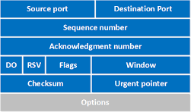

1. Source Port (16 bits)
Identifies the application that is sending the data.
Example:
Chrome Browser → Google Server
Chrome may use:
Source Port = 54321
This is usually a temporary (ephemeral) port.

Purpose
When Google replies, it knows where to send the response.

2. Destination Port (16 bits)
Identifies the application that should receive the data.
Example:
HTTPS Website
Port:
443
TCP Header:
Destination Port = 443

Common Ports
Service | Port
HTTP | 80
HTTPS | 443
SSH | 22
FTP | 21

Example
You open Google:
Your PC Google Server
Port 54321 ---> Port 443
TCP Header contains:
Source Port = 54321
Destination Port = 443

3. Sequence Number (32 bits)
One of the most important fields.
TCP numbers every byte sent.
This field tells:
Which byte is being sent first in this segment?

Example
Suppose:
HELLO
contains 5 bytes.
TCP may send:
Sequence Number = 1000
Meaning:
H = byte 1000
E = byte 1001
L = byte 1002
L = byte 1003
O = byte 1004

Why Needed?
If packets arrive out of order:
Packet 3 arrives first
Packet 1 arrives second
Packet 2 arrives third
TCP can reorder them using sequence numbers.

4. Acknowledgment Number (32 bits)
Used for reliability.
Tells:
What is the next byte expected?

Example
Sender sends:
Bytes 1000-1499
Receiver successfully receives them.
It sends:
ACK = 1500
Meaning:
I received everything up to 1499.
Now send byte 1500.

Why Useful?
If ACK doesn't arrive:
TCP assumes packet loss and retransmits.

5. Header Length (HLEN/Data Offset)
Usually:
4 bits
Tells:
Where the actual data begins.
Because TCP headers may have optional fields.

Example:
Header = 20 bytes
or
Header = 32 bytes
The receiver must know where payload starts.

6. Reserved Bits
Reserved for future use.
Normally:
000
Not usually discussed in interviews.

7. Flags (Control Bits)
These are extremely important.
Flags control TCP behavior.

Main TCP Flags
Flag | Meaning
SYN | Start connection
ACK | Acknowledgment
FIN | Close connection
RST | Reset connection
PSH | Push data immediately
URG | Urgent data

SYN
Used during connection setup.
Example:
Client → SYN
Meaning:
I want to connect.

ACK
Acknowledges received data.
Example:
ACK = 5000
Meaning:
I received bytes before 5000.

FIN
Used to terminate a connection.
Example:
FIN
Meaning:
I'm done sending data.

RST
Reset connection immediately.
Used when:
Port closed
Invalid connection

PSH
Push data immediately to the application.
Normally TCP may buffer data.
PSH says:
Deliver now.

URG
Indicates urgent data.
Rarely used today.

8. Window Size (16 bits)
Used for Flow Control.
Tells:
How much data can be received right now?

Example
Receiver says:
Window Size = 5000 bytes
Meaning:
You can send 5000 more bytes.

Why Needed?
Suppose:
Sender speed:
100 MB/s
Receiver speed:
10 MB/s
Without window size:
Receiver buffer would overflow.
TCP prevents this.

9. Checksum (16 bits)
Used for Error Detection.
TCP computes a checksum before sending.
Receiver computes checksum again.

Example
Sender:
Checksum = ABCD
Receiver calculates:
ABCD
Match:
Packet accepted
Not match:
Packet discarded

Why Important?
Detects:
- Bit errors
- Corrupted packets

10. Urgent Pointer (16 bits)
Used with URG flag.
Tells where urgent data ends.
Example:
URG = 1
Urgent Pointer = 50
Meaning:
First 50 bytes are urgent.
Rarely used nowadays.

11. Options (Variable Length)
Additional TCP features.
Common options:

MSS (Maximum Segment Size)
Tells:
Largest packet size I can receive
Example:
MSS = 1460 bytes

Window Scaling
Allows windows larger than:
65535 bytes
Useful in high-speed networks.

Timestamp
Measures RTT (Round Trip Time).
Used to improve performance.

SACK (Selective Acknowledgment)
Allows receiver to tell exactly which blocks were received.
Without SACK:
Resend many packets
With SACK:
Resend only missing packets
Much more efficient.

Real Example: Opening Google
When you visit:
https://google.com
First packet:
Source Port = 54321
Destination Port = 443
Sequence Number = 1000
ACK Number = 0
Flag = SYN
Window Size = 65535
Checksum = Valid
Server replies:
Source Port = 443
Destination Port = 54321
Sequence Number = 5000
ACK Number = 1001
Flags = SYN, ACK
Then client sends:
ACK
and the connection is established.

3. UDP (User Datagram Protocol)
UDP is the opposite of TCP.
Think of UDP like:
📢 Announcing on a loudspeaker.
You speak once.
You don't check whether everyone heard it.

UDP Features

A. Fast
No acknowledgments.
No waiting.
No retransmission.

B. Connectionless
No connection setup.
Just send data.
Example:
Send Packet
Done

C. No ACK
Sender never asks:
Did you receive it?

D. No Ordering
Packets may arrive:
3
1
2
Application receives:
3
1
2
exactly as received.

E. Lower Overhead
TCP header:
20 bytes+
UDP header:
8 bytes
Much smaller.

Why UDP is Faster
TCP:
Connect
Send
Wait ACK
Send
Wait ACK
UDP:
Send
Send
Send
Send
No waiting.

UDP Uses

DNS
When your browser asks:
What is google.com IP?
DNS usually uses UDP Port 53.
Because response is small and speed matters.

Video Streaming
Examples:
- YouTube Live
- Netflix Live
Missing one frame is okay.
Speed is more important.

Online Gaming
Games need:
- Fast updates
- Low latency
Not perfect delivery.

VoIP
Voice Calls:
- WhatsApp Calls
- Zoom
- Google Meet
If one packet is lost:
You hear a tiny glitch.
Better than waiting for retransmission.

TCP vs UDP
Feature | TCP | UDP
Reliable | Yes | No
ACK | Yes | No
Ordered | Yes | No
Retransmission | Yes | No
Speed | Slower | Faster
Connection | Connection-Oriented | Connectionless
Header Size | 20+ Bytes | 8 Bytes
Use Cases | HTTP, HTTPS, SSH | DNS, VoIP, Streaming

4. TCP Three-Way Handshake
Before sending actual data, TCP establishes a connection.
This process is called:

TCP Three-Way Handshake
Interviewers love this question.

Why Needed?
Both sides need to know:
- Is the other side alive?
- Can it receive data?
- Can it send data?

Step 1: SYN
Client → Server
SYN
Meaning:
Hello, I want to connect.
Example:
Browser → Web Server
SYN

Step 2: SYN-ACK
Server → Client
SYN + ACK
Meaning:
I received your request and I am ready.

Step 3: ACK
Client → Server
ACK
Meaning:
Great, let's start communication.

Visualization
CLIENT SERVER
SYN -------------------->
<---------------- SYN-ACK
ACK -------------------->
Connection Established
After this:
HTTP Request
HTTP Response
can start.

Real Browser Example
When you open:
https://google.com
Your computer first does:
SYN
SYN-ACK
ACK
Then:
GET /
Then Google sends the webpage.

Why Not Just Two Steps?
Suppose:
Client → SYN
Server → ACK
The client still doesn't know whether the server actually received the ACK properly and is ready for communication.
The third ACK confirms that both sides can send and receive, making the connection fully established.

Easy Interview Answer
What is TCP?
TCP is a reliable, connection-oriented transport layer protocol that provides acknowledgments, retransmission, ordered delivery, flow control, and congestion control.
What is UDP?
UDP is a fast, connectionless transport layer protocol that does not provide acknowledgments, retransmission, or guaranteed delivery.
Explain TCP Three-Way Handshake.
TCP establishes a connection using three steps:
- SYN – Client requests connection.
- SYN-ACK – Server acknowledges and accepts.
- ACK – Client confirms.
After these three steps, the TCP connection is established and data transfer begins.

16. DNS (Domain Name System)
DNS is often called:
The Internet's Phonebook
Humans remember names:
google.com
youtube.com
amazon.com
Computers communicate using IP addresses:
142.250.193.14
172.217.160.110
DNS converts:
google.com
↓
142.250.193.14

Why DNS is Needed?
Imagine if Google told users:
Visit us at 142.250.193.14
Nobody would remember that.
Instead we use:
google.com
DNS does the translation automatically.

What Happens When You Open Google?
You type:
https://google.com

Step 1
Browser checks cache.
Do I already know Google's IP?
If yes:
Use cached IP
If no:
Proceed to DNS lookup.

Step 2
Computer asks DNS server:
What is the IP of google.com?

Step 3
DNS server replies:
142.250.xxx.xxx

Step 4
Browser now contacts that IP.
Your PC
↓
Google IP
Website loads.

DNS Hierarchy
Root DNS
↓
.com DNS
↓
google.com DNS
↓
IP Address

What is DNS?
DNS (Domain Name System) translates:
google.com
↓
142.250.193.14
because computers communicate using IP addresses, not domain names.
Think of DNS as:
Contact Name → Phone Number
Vinu → 9876543210
Domain Name → IP Address
google.com → 142.250.193.14

The DNS Hierarchy
The DNS system is organized like a tree.
Root DNS (.)
|
--------------------------------
| | |
.com .org .net
|
google.com
|
www.google.com
There are three important levels:
- Root DNS Servers
- TLD DNS Servers
- Authoritative DNS Servers
Let's understand each.

1. Root DNS Servers
At the very top are Root DNS Servers.
.
(the dot represents the root).
They don't know Google's IP.
Instead they know:
Who manages .com ?
Who manages .org ?
Who manages .net ?

Example
Suppose you ask:
What is google.com?
Root DNS replies:
I don't know.
But .com DNS servers know.
Go ask them.

2. TLD DNS Servers
TLD = Top Level Domain
Examples:
.com
.org
.net
.edu
.in
TLD servers know:
Who manages google.com?
Who manages amazon.com?
Who manages microsoft.com?
but they don't know the IP address.

Example
You ask .com DNS:
What is google.com?
TLD DNS replies:
I don't know the IP.
But Google's DNS server knows.
Ask ns1.google.com

3. Authoritative DNS Server
This is where the actual records exist.
Example:
google.com
Google maintains authoritative DNS servers.
These contain:
A Records
AAAA Records
MX Records
CNAME Records
etc.

Complete DNS Lookup Example
Suppose you open:
https://google.com

Step 1: Browser Cache
Browser checks:
Do I already know Google's IP?
If yes:
Use cached IP
If no:
Continue.

Step 2: OS Cache
Operating system checks cache.
Windows/Linux cache
No result?
Continue.

Step 3: DNS Resolver
Your computer asks:
ISP DNS
Google DNS (8.8.8.8)
Cloudflare DNS (1.1.1.1)
Example:
What is google.com?

Step 4: Resolver asks Root DNS
What is google.com?
Root DNS:
Ask .com servers.

Step 5: Resolver asks .com TLD
What is google.com?
TLD DNS:
Ask Google's authoritative DNS.

Step 6: Resolver asks Authoritative DNS
What is google.com?
Authoritative DNS:
142.250.193.14

Step 7: Result Returned
Resolver sends:
google.com
↓
142.250.193.14
back to your computer.

Step 8: Browser Connects
Now TCP connection starts:
Your PC
↓
142.250.193.14
and Google opens.

DNS Lookup Diagram
User
|
| google.com?
|
DNS Resolver
|
+-------------------+
| Root DNS |
+-------------------+
|
v
.com TLD DNS
|
v
Authoritative DNS
|
v
142.250.193.14
|
v
User

Understanding DNS Records
These records are stored inside the Authoritative DNS Server.

1. A Record
A = Address
Maps:
Domain → IPv4 Address
Example:
google.com
↓
142.250.193.14
DNS Record:
A Record

Real Example
mywebsite.com
↓
192.168.1.10
DNS Zone:
A mywebsite.com 192.168.1.10

Interview Answer
A Record maps a domain name to an IPv4 address.

2. AAAA Record
Maps:
Domain → IPv6 Address
Example:
google.com
↓
2404:6800:4009::200e
DNS Record:
AAAA Record

Why AAAA?
IPv4:
192.168.1.10
IPv6:
2404:6800:4009::200e
needs a different record type.

Easy Trick
A → IPv4
AAAA → IPv6

3. CNAME Record
CNAME = Canonical Name
Creates an alias.
Maps:
Domain → Domain
not Domain → IP.

Example
www.google.com
↓
google.com
DNS:
CNAME Record

How it Works
When user asks:
www.google.com
DNS says:
Use google.com instead.
Then DNS performs lookup for:
google.com
and gets the IP.

Cloud Example
Suppose AWS Load Balancer has:
abc123.elb.amazonaws.com
You create:
app.company.com
DNS:
app.company.com
↓
abc123.elb.amazonaws.com
using CNAME.
Very common in AWS.

4. MX Record
MX = Mail Exchange
Used for email delivery.

Problem
Suppose someone sends:
vinu@gmail.com
How does the sender know where Gmail receives emails?
Answer:
MX Record.

Example
DNS Query:
gmail.com MX
Response:
gmail-smtp-in.l.google.com

Email Flow
Sender
|
| vinu@gmail.com
|
DNS Query
|
| MX Record?
|
gmail mail server
|
v
Email Delivered

Without MX Record
Email cannot be delivered.

Interview Answer
MX Record specifies which mail servers handle email for a domain.

5. NS Record
NS = Name Server
One of the most important records.

Purpose
Tells:
Who is responsible for this domain?

Example
For:
mywebsite.com
NS records may be:
ns1.hostinger.com
ns2.hostinger.com
Meaning:
These DNS servers contain all
records for mywebsite.com

Why Important?
When TLD DNS receives:
mywebsite.com?
it checks NS records.
Then it says:
Ask these DNS servers.

Real DNS Zone Example
Imagine your website:
vinu.com
DNS records may look like:
A
vinu.com
→ 43.205.100.10
AAAA
vinu.com
→ 2404:6800::1
CNAME
www.vinu.com
→ vinu.com
MX
vinu.com
→ mail.vinu.com
NS
vinu.com
→ ns1.hostinger.com
→ ns2.hostinger.com

Most Important Interview Question

What happens when you type google.com in a browser?
Answer:
- Browser checks cache.
- OS checks cache.
- DNS Resolver receives query.
- Resolver asks Root DNS.
- Root DNS points to .com TLD DNS.
- TLD DNS points to Google's Authoritative DNS.
- Authoritative DNS returns the A Record (IP address).
- Resolver returns IP to browser.
- Browser establishes TCP connection.
- Website loads.

Why DNS is Important in Cloud?
Almost every cloud service uses DNS.
Examples:

Load Balancer
app.company.com
↓
AWS Load Balancer

Website
shop.company.com
↓
EC2 Instance

API
api.company.com
↓
Kubernetes Service

Cloud applications would be difficult to manage without DNS.

17. Firewall
A Firewall is a security device/software that controls which network traffic is allowed or blocked.
Think of it as a security guard at a building entrance.
- Allowed traffic → enters
- Blocked traffic → denied

Why Firewall is Needed?
Without a firewall:
Internet
↓
Server
Anyone can try to access your server.
With a firewall:
Internet
↓
Firewall
↓
Server
The firewall checks every packet before allowing it.

Example
Suppose your web server has IP:
10.0.1.5
You want:
- Allow HTTP (80)
- Allow HTTPS (443)
- Allow SSH (22)
- Block everything else
Firewall Rules:
Port | Action
80 | Allow
443 | Allow
22 | Allow
Any Other | Deny

Packet Flow
A packet arrives:
Source IP: 1.2.3.4
Destination IP: 10.0.1.5
Port: 80
Firewall checks:
Is port 80 allowed?
Yes
Packet enters.

Another packet:
Source IP: 5.6.7.8
Destination IP: 10.0.1.5
Port: 3306
Firewall:
Port 3306 not allowed
Packet dropped.

Stateful Firewall
Modern cloud firewalls are usually stateful.
Meaning:
When you initiate a connection:
Laptop → Server
Return traffic is automatically allowed.
No need to create separate rules.

Stateless Firewall
Checks every packet individually.
Doesn't remember connections.
Less intelligent.
More work for administrators.

Cloud Examples

AWS Security Groups
Security Group = Virtual Firewall attached to resources.
Example:
EC2 Instance
↓
Security Group
Rules:
Allow:
SSH 22
HTTP 80
HTTPS 443
Everything else denied.
Important:
✅ Stateful
Meaning:
Incoming SSH Allowed
Response packets automatically allowed.

AWS NACL
NACL = Network Access Control List
Applied at subnet level.
Example:
VPC
├── Public Subnet
│ ↓
│ NACL
│
└── Private Subnet
↓
NACL
Characteristics:
- Stateless
- Allow Rules
- Deny Rules
Must configure both inbound and outbound.

Azure NSG
NSG = Network Security Group
Works like Security Group.
Attached to:
- VM
- Subnet
Rules:
Allow 80
Allow 443
Allow 22
Everything else denied.
Stateful firewall.

Security Group vs NACL
Feature | Security Group | NACL
Level | Instance | Subnet
Stateful | Yes | No
Allow Rules | Yes | Yes
Deny Rules | No | Yes
AWS Service | SG | NACL
Interview favorite question.

18. ACL (Access Control List)
ACL is simply a list of rules that decides:
Who can access what?

Example ACL
Allow:
192.168.1.10
Deny:
192.168.1.20
Meaning:
192.168.1.10 → Allowed
192.168.1.20 → Blocked

Example
Office Network:
Employee PC
↓
Server
ACL:
Allow:
192.168.1.0/24
Deny:
All Others
Only office employees can access server.

ACL Structure
Usually contains:

Source IP
Example:
192.168.1.10

Destination IP
Example:
10.0.0.5

Protocol
Example:
TCP
UDP
ICMP

Port
Example:
22
80
443

Action
Allow
Deny

ACL Rule Processing
Rules checked from top to bottom.
Example:
Rule 1:
Deny 192.168.1.50
Rule 2:
Allow 192.168.1.0/24
Traffic:
192.168.1.50
Matches Rule 1 first.
Result:
Denied
Even though Rule 2 allows entire subnet.
This is called:

First Match Wins
Very important.

19. NAT (Network Address Translation)
One of the most important cloud networking concepts.

Problem NAT Solves
Private IPs cannot access the internet directly.
Example:
10.0.0.5
This is a private IP.
Internet routers don't route private IPs.

Without NAT
Private Server
10.0.0.5
↓
Internet
Internet says:
I don't know where 10.0.0.5 exists.
Connection fails.

NAT Solution
NAT converts:
Private IP
↓
Public IP
Example:
10.0.0.5
↓
203.0.113.10
Now internet can communicate.

NAT Working
Server:
10.0.0.5
Requests:
google.com
Packet:
Source IP:
10.0.0.5
NAT changes:
Source IP:
203.0.113.10
Google replies:
Destination:
203.0.113.10
NAT translates back:
203.0.113.10
↓
10.0.0.5
Response reaches server.

Types of NAT

1. Static NAT
One private IP ↔ One public IP
10.0.0.5
↔
52.10.10.10
Permanent mapping.

Use Case
Web Server
Private:
10.0.0.5
Public:
52.10.10.10
Always same public IP.

2. Dynamic NAT
Many public IPs available.
Example:
Private IPs:
10.0.0.5
10.0.0.6
10.0.0.7
Public Pool:
52.1.1.1
52.1.1.2
52.1.1.3
NAT assigns one dynamically.
Not fixed.

3. PAT (Port Address Translation)
Most common today.
Also called:
NAT Overload

Example
Private Devices:
10.0.0.5
10.0.0.6
10.0.0.7
All use one public IP:
52.1.1.1
How?
Using port numbers.

Translation Table
Private IP | Private Port | Public IP | Public Port
10.0.0.5 | 5000 | 52.1.1.1 | 10001
10.0.0.6 | 5000 | 52.1.1.1 | 10002
10.0.0.7 | 5000 | 52.1.1.1 | 10003
This allows thousands of devices to share one public IP.

Cloud Example: NAT Gateway
One of the most important AWS interview topics.

Problem
Private subnet servers need internet access:
- Software updates
- Install packages
- Access APIs
But should not be reachable from internet.

Architecture
Internet
↑
NAT Gateway
↑
Public Subnet
↑
Private Subnet
↑
EC2

Flow
Private EC2:
10.0.2.5
Requests:
apt update
Packet goes:
EC2
↓
Route Table
↓
NAT Gateway
↓
Internet
NAT Gateway converts:
10.0.2.5
↓
Public IP
Internet responds.
Response comes back through NAT Gateway.

Important Point
Internet cannot initiate traffic to private EC2.
Allowed:
Private EC2 → Internet
Not Allowed:
Internet → Private EC2
This is why NAT Gateway is considered secure.

NAT Gateway vs Internet Gateway
Feature | NAT Gateway | Internet Gateway
Public Internet Access | Outbound Only | Inbound + Outbound
Public IP Required on EC2 | No | Yes
Private Subnet Usage | Yes | No
Internet Can Reach Server | No | Yes

Easy Interview Summary
- Firewall = Controls traffic.
- ACL = List of Allow/Deny rules.
- NAT = Converts Private IP ↔ Public IP.
- Static NAT = One-to-One mapping.
- Dynamic NAT = Pool of public IPs.
- PAT = Many private IPs share one public IP using ports.
- Security Group = Stateful firewall (instance level).
- NACL = Stateless firewall (subnet level).
- NAT Gateway = Allows private subnet resources to access the internet without exposing them to inbound internet traffic.

20. VPN (Virtual Private Network)
A VPN creates a secure encrypted tunnel over a public network (usually the Internet).
Think of it as:
"Using the Internet as a private network."

Why VPN is Needed?
Suppose your laptop is connected to a coffee shop Wi-Fi.
Without VPN:
Laptop
↓
Internet
↓
Company Server
Data travels normally.
An attacker on the network may try to inspect traffic.

With VPN
Laptop
↓
Encrypted Tunnel
↓
VPN Server
↓
Company Network
Data is encrypted before leaving your laptop.
Anyone intercepting packets sees:
%$#@!@#^&*^#@!
instead of actual data.

What VPN Provides

1. Encryption
Protects data from attackers.
Example:
Username: vinit
Password: 12345
becomes encrypted.

2. Privacy
Others cannot easily see what data you're sending.

3. Secure Remote Access
Employees can access company resources from home.
Example:
Home Laptop
↓
VPN
↓
Office Network
The laptop behaves almost as if it were inside the office.

VPN Tunnel
A VPN creates a logical tunnel.
Laptop
════════════════
Encrypted Tunnel
════════════════
VPN Server
Data inside the tunnel is encrypted.

Site-to-Site VPN (Cloud Interview Favorite)
Used to connect two networks securely.
Example:
Office Network
192.168.1.0/24
│
│ VPN Tunnel
│
10.0.0.0/16
AWS VPC

Real Example
Company office:
192.168.1.0/24
AWS VPC:
10.0.0.0/16
Without VPN:
Office ❌ AWS
No direct secure connection.
With VPN:
Office
↓
Encrypted Tunnel
↓
AWS VPC
Resources communicate securely.

AWS Site-to-Site VPN
Components:
Customer Gateway
↓
VPN Tunnel
↓
Virtual Private Gateway

Customer Gateway
Your office router/firewall.

Virtual Private Gateway
AWS side VPN endpoint.

VPN Tunnel
Encrypted connection.

Example Flow
Office Server
192.168.1.10
Wants to access:
AWS Database
10.0.1.20
Packet Flow:
Office Server
↓
Customer Gateway
↓
Encrypted VPN Tunnel
↓
Virtual Private Gateway
↓
AWS Database

Types of VPN

Remote Access VPN
One user connects.
Laptop
↓
VPN
↓
Company
Example:
- Employee working from home

Site-to-Site VPN
Entire networks connect.
Office Network
↓
VPN
↓
AWS VPC
Example:
- Company office connected to AWS

VPN vs Internet
Without VPN:
Data
↓
Visible on Internet
With VPN:
Data
↓
Encrypted
↓
Internet

VPN vs Direct Connect
Feature | VPN | Direct Connect
Uses Internet | Yes | No
Cost | Low | High
Setup | Easy | Complex
Speed | Lower | Higher
Encryption | Yes | Usually No
In cloud environments:
- Small companies → VPN
- Large enterprises → Dedicated connections

Step 1: What is a Proxy?
A proxy is simply a middleman.
Instead of:
Client → Server
You do:
Client → Proxy → Server
The proxy receives the request first and then forwards it.

Real Life Example
Suppose you want to buy something.
Without a middleman:
You → Shop
With a middleman:
You → Agent → Shop
The shop talks to the agent, not directly to you.
That agent is acting like a proxy.

Forward Proxy

Who does it represent?
It represents the CLIENT.
Client → Forward Proxy → Internet
The proxy is standing on behalf of the client.

Example
Your laptop:
IP = 192.168.1.10
Forward Proxy:
IP = 50.50.50.50
Google:
google.com

Without Forward Proxy
Laptop
↓
Google
Google sees:
192.168.1.10

With Forward Proxy
Laptop
↓
Forward Proxy
↓
Google
Google sees:
50.50.50.50
Google does NOT know your laptop exists.
It thinks the proxy made the request.

Actual Packet Flow

Step 1
Laptop sends request:
GET google.com
to proxy.

Step 2
Proxy receives it.
Laptop
↓
Proxy

Step 3
Proxy forwards to Google.
Proxy
↓
Google

Step 4
Google replies to Proxy.
Google
↓
Proxy

Step 5
Proxy sends response back.
Proxy
↓
Laptop

Why Companies Use Forward Proxy
Suppose 100 employees exist.
Employee PCs
↓
Forward Proxy
↓
Internet
Company can control internet access.

Block Websites
Example:
facebook.com
Employee tries:
Laptop
↓
Proxy
Proxy checks:
facebook.com
Blocked.
Request never reaches Facebook.

Monitor Traffic
Company can see:
Employee A visited:
youtube.com
Employee B visited:
google.com

Cache Content
Suppose 100 employees download same file.
Without cache:
Internet → 100 downloads
Huge bandwidth usage.
With cache:
First request → Internet
Remaining requests → Proxy Cache
Faster.

Memory Trick
Forward Proxy is close to clients.
Clients
↓
Forward Proxy
↓
Internet
So:
Forward Proxy protects clients.

Reverse Proxy
Now let's flip everything.

Who does it represent?
It represents the SERVERS.
Client
↓
Reverse Proxy
↓
Servers
Clients talk to proxy.
They never talk directly to servers.

Example
Suppose you own a website:
myapp.com
Backend server:
10.0.0.5

Without reverse proxy:
User
↓
10.0.0.5
Users directly reach your server.

With reverse proxy:
User
↓
Nginx
↓
10.0.0.5
Users only know Nginx.
They don't know where backend lives.

Actual Flow
User enters:
https://myapp.com

Step 1
Request reaches Nginx.
Client
↓
Nginx

Step 2
Nginx forwards.
Nginx
↓
Node.js App

Step 3
Node.js generates response.
Node.js
↓
Nginx

Step 4
Nginx returns response.
Nginx
↓
Client

Client never directly talks to Node.js.

Why Reverse Proxy Is Used

1. Security
Without reverse proxy:
Internet
↓
Backend Server
Attackers know server location.

With reverse proxy:
Internet
↓
Nginx
↓
Backend
Backend is hidden.

2. Load Balancing
Suppose your website gets 1 million users.
One server cannot handle it.
Use multiple servers.
Server1
/
Client → Nginx
\
Server2
\
Server3
Nginx distributes traffic.

Example:
Request 1 → Server1
Request 2 → Server2
Request 3 → Server3

This is called:

Load Balancing

3. SSL Termination
Normally:
Client
↓ HTTPS
Backend
Backend must encrypt/decrypt every request.
Heavy work.

Instead:
Client
↓ HTTPS
Nginx
↓ HTTP
Backend
Nginx handles SSL.
Backend does less work.

4. Caching
Suppose homepage rarely changes.
/
Nginx stores copy.
Next request:
Client
↓
Nginx Cache
No need to hit backend.
Much faster.

Nginx Example
Very common interview question.
Your MERN application:
React
Node.js
MongoDB
Node.js running on:
localhost:3000
Nginx running on:
Port 80
Port 443
Flow:
User
↓
Nginx
↓
localhost:3000
User thinks:
myapp.com
But Nginx internally forwards to:
localhost:3000

HAProxy Example
HAProxy mainly focuses on load balancing.
Server1
/
Client → HAProxy
\
Server2
\
Server3
HAProxy decides:
Request A → Server1
Request B → Server2
Request C → Server3

The Easiest Way To Remember

Forward Proxy
Ask:

"Who is hidden?"
Client → Proxy → Internet
Client is hidden.
Therefore:
✅ Represents Client
✅ Protects Client

Reverse Proxy
Ask:

"Who is hidden?"
Client → Proxy → Server
Server is hidden.
Therefore:
✅ Represents Server
✅ Protects Server

Final Interview Diagram

Forward Proxy
Employee
↓
Forward Proxy
↓
Google
Google sees:
Proxy IP
Not employee IP.

Reverse Proxy
User
↓
Nginx
↓
Backend Servers
User sees:
Nginx
Not backend server IPs.

One-Line Interview Answer
Forward Proxy: Sits in front of clients and hides client identities from servers.
Reverse Proxy: Sits in front of servers and hides server identities from clients while providing security, load balancing, SSL termination, and caching.

F. Web Protocols (Very Important for Cloud & Networking)

22. HTTP (HyperText Transfer Protocol)
HTTP is the protocol used by web browsers and web servers to communicate.
When you open a website:
Browser ───────HTTP Request──────► Web Server
Browser ◄─────HTTP Response────── Server
Example:
You type:
http://example.com
Browser sends:
GET / HTTP/1.1
Host: example.com
Server responds:
HTTP/1.1 200 OK
Welcome to Example Website

Port Number
HTTP uses:
Port 80
Example:
http://google.com:80
Normally the browser hides port 80 because it is the default HTTP port.

Problem with HTTP
HTTP sends data as plain text.
Example:
Username: vinit
Password: 12345
An attacker can capture packets and read everything.
Client
↓
Network
↓
Attacker can read
↓
Server
Therefore HTTP is:
❌ Not secure
❌ No encryption
❌ No confidentiality

23. HTTPS (HyperText Transfer Protocol Secure)
HTTPS is HTTP + SSL/TLS Security.
HTTPS = HTTP + TLS
When you open:
https://google.com
Browser and server establish a secure connection first.
Then HTTP data travels inside an encrypted tunnel.
Browser
↓
Encrypted Connection
↓
Web Server

Port Number
HTTPS uses:
Port 443
Example:
https://google.com:443
Port 443 is default, so browsers hide it.

Why HTTPS?
Suppose login details are:
Username: vinit
Password: mypassword
HTTP:
Attacker sees everything
HTTPS:
Attacker sees encrypted data
A9F4C3D21A8B...
Cannot understand the content.

Benefits of HTTPS

1. Encryption
Data becomes unreadable.

2. Authentication
Ensures you're talking to the real server.

3. Integrity
Ensures data wasn't modified.

24. SSL/TLS
SSL = Secure Sockets Layer
TLS = Transport Layer Security
Today:
SSL = Old
TLS = New
People still say "SSL certificate," but modern systems use TLS.

Where Does TLS Work?
TLS works between:
Application Layer
↑
TLS
↑
Transport Layer (TCP)
Stack:
HTTP
TLS
TCP
IP
Ethernet

What Does TLS Provide?
TLS provides the famous:

CIA Triad

1. Confidentiality
Meaning:
Only sender and receiver can read data.

Without Confidentiality
Client
↓
password=12345
↓
Network
↓
Server
Anyone capturing packets can read it.

With Confidentiality
password=12345
becomes
A7F93B12C4E8...
Attacker sees:
A7F93B12C4E8...
Cannot understand it.

Achieved Through Encryption
Encryption:
Plain Text
↓
Encryption Algorithm
↓
Cipher Text
Example:
HELLO
becomes
X7P91A

2. Integrity
Meaning:
Data should not be altered during transmission.

Example:
Original:
Transfer ₹100
Attacker changes:
Transfer ₹10000
This violates integrity.

How TLS Ensures Integrity
Uses:
Hash Functions
Examples:
SHA-256
SHA-384

Hash Example
Message:
HELLO
Hash:
2CF24DBA...
If even one character changes:
HELLo
New hash:
9A7F3D12...
Completely different.

Why?
Server calculates hash again.
If hashes differ:
Data modified
Connection rejected.

3. Authentication
Meaning:
Verify identity.
Question:
How do I know this is really google.com?
Not:
Fake Hacker Server

Authentication Uses Certificates
The server sends a certificate.
Browser checks:
Is certificate valid?
Is certificate trusted?
Is certificate expired?
If yes:
Connection trusted

Digital Certificate
Think of it like a digital ID card.
Contains:
Website Name
Public Key
Issuer
Expiry Date
Owner Information
Example:
google.com
Certificate says:
This website belongs to Google

Certificate Authority (CA)
A CA is a trusted organization that issues certificates.
Examples:
- DigiCert
- Let's Encrypt
- GlobalSign

How Certificate Validation Works

Step 1
Browser visits:
https://google.com

Step 2
Server sends certificate.
Google Server
↓
Certificate
↓
Browser

Step 3
Browser verifies:
Trusted CA?
Certificate Valid?
Domain Matches?
Expired?

Step 4
If valid:
Secure Connection Established
Browser shows:
🔒 Padlock

TLS Handshake (Interview Favorite)
Before sending encrypted data:
Client
↔
Server
perform a TLS Handshake.

Simplified TLS Handshake

Step 1: Client Hello
Browser says:
Hi Server
I support:
TLS 1.2
TLS 1.3
Supported Cipher Suites:
AES
ChaCha20

Step 2: Server Hello
Server replies:
Let's use:
TLS 1.3
AES-256
and sends certificate.

Step 3: Certificate Verification
Browser verifies certificate.

Step 4: Key Exchange
Both sides securely create session keys.
Client Key
Server Key

Step 5: Secure Channel Created
Now:
HTTP Data
travels through:
Encrypted TLS Tunnel

HTTP vs HTTPS
Feature | HTTP | HTTPS
Port | 80 | 443
Encryption | ❌ | ✅
Authentication | ❌ | ✅
Integrity | ❌ | ✅
Secure Login | ❌ | ✅
Certificates | ❌ | ✅
TLS/SSL | ❌ | ✅

Cloud Interview Questions

Q1. HTTP uses which port?
80

Q2. HTTPS uses which port?
443

Q3. HTTPS is built using?
HTTP + TLS

Q4. What does TLS provide?
Confidentiality
Integrity
Authentication

Q5. What is the difference between SSL and TLS?
SSL = Older protocol (deprecated)
TLS = Modern secure protocol

Q6. What is a digital certificate?
A digital identity card for a website that proves the server's authenticity and contains its public key.

Q7. Why is HTTPS preferred in cloud environments?
Because cloud applications transfer sensitive data,
and HTTPS provides encryption, authentication,
and integrity using TLS.
For cloud networking interviews, remember this flow:
Browser
↓
HTTPS (443)
↓
TLS Handshake
↓
Certificate Validation
↓
Session Key Creation
↓
Encrypted Communication
↓
Web Server
This complete flow is one of the most commonly asked networking and cloud interview topics.

Why Do We Need a TLS Handshake?
Suppose your browser wants to connect to:
https://google.com
The browser and server have never met before.
Questions:
How can they trust each other?
How can they create encryption keys?
How can they start encrypted communication?
The answer is:
TLS Handshake
The handshake happens before any actual website data is sent.

Real-Life Analogy
Imagine you want to talk secretly with your friend.
You first:
1. Verify your friend
2. Agree on a secret language
3. Create a secret code
4. Start talking
TLS does exactly this.

TLS Handshake Overview
Client (Browser)
│
│ Client Hello
▼
Server
│
│ Server Hello + Certificate
▼
Client
│
│ Verify Certificate
▼
Both Create Session Key
▼
Encrypted Communication Starts

Step 1: Client Hello
Browser starts the conversation.
Browser
↓
Client Hello
The browser sends:

Supported TLS Versions
Example:
TLS 1.2
TLS 1.3
Meaning:
I can speak these versions.

Supported Cipher Suites
Cipher Suite = Encryption methods.
Example:
AES-256
ChaCha20
Meaning:
These are the encryption algorithms I support.

Random Number
Browser generates a random number.
Example:
Client Random = X123
Used later to generate session keys.

Step 2: Server Hello
Server responds:
Server Hello
Server says:
Let's use TLS 1.3
Let's use AES-256
Server also sends:
Server Random = Y456

Step 3: Server Sends Certificate
Very important step.
Server sends:
Digital Certificate
Contains:
Domain Name
Public Key
Issuer
Expiry Date
Example:
google.com
Public Key = ABC123
Issued By = DigiCert

Why Is Certificate Needed?
Without certificates:
Browser
↓
Hacker pretending to be Google
Browser would have no way to know.
Certificate proves:
I am really Google.

Step 4: Browser Verifies Certificate
Browser checks:

Domain Match
Certificate says:
google.com
Requested:
google.com
✓ Valid

Certificate Expiry
Expired?
If expired:
Connection Warning

Trusted CA
Browser contains a list of trusted Certificate Authorities.
Examples:
- DigiCert
- Let's Encrypt
If the certificate is signed by a trusted CA:
✓ Trust Server

Step 5: Key Exchange
Now both sides need a secret key.
Remember:
Encryption needs a key.
Most modern TLS uses:
ECDHE
(Elliptic Curve Diffie-Hellman Ephemeral)
Don't worry about the name now.
Purpose:
Generate a shared secret key
without sending it over the network.
This is the magic part.

Simple Example
Client has:
Secret A
Server has:
Secret B
Using math:
Client + Server
↓
Shared Secret
Attacker sees packets but cannot calculate the shared secret.

Step 6: Session Key Created
Using:
Client Random
Server Random
Shared Secret
Both generate:
Session Key
Example:
K = XYZ789
Both have the same key.

Step 7: Secure Communication Begins
Now browser sends:
GET /index.html
Before transmission:
Plain Text
↓
AES Encryption
↓
Cipher Text
Attacker sees:
A7D91C3F8E...
Not readable.

What Is a Session Key?
Session Key is:
Temporary Encryption Key
Used only for that connection.
When connection closes:
Session Key destroyed
Next connection:
New Session Key
This improves security.

Complete TLS Handshake Flow
Browser
│
├── Client Hello
│
Server
│
├── Server Hello
├── Certificate
│
Browser
│
├── Verify Certificate
│
Both
│
├── Key Exchange
├── Generate Session Key
│
▼
Encrypted Communication

Why Did TLS Replace SSL?
SSL came first.
Timeline:
SSL 1.0 ❌ Never released
SSL 2.0 ❌ Broken
SSL 3.0 ❌ Vulnerable
TLS 1.0 ✅ Improved SSL
TLS 1.1 ✅ Better
TLS 1.2 ✅ Strong
TLS 1.3 ✅ Current Standard

Problems with SSL
SSL had many security weaknesses.
Attackers found vulnerabilities like:

POODLE Attack
Affected:
SSL 3.0
Allowed attackers to decrypt traffic.

Weak Encryption
SSL used older algorithms.
Examples:
MD5
SHA-1
RC4
These became insecure over time.

Poor Handshake Security
SSL handshake had weaknesses that allowed:
Downgrade attacks
Man-in-the-Middle attacks

What TLS Improved

Stronger Encryption
TLS supports:
AES
ChaCha20
instead of weak algorithms.

Better Authentication
More secure certificate validation.

Better Integrity Checking
Uses stronger hashing:
SHA-256
SHA-384
instead of weaker hashes.

Forward Secrecy
One of the biggest improvements.
Suppose a hacker steals the server's private key tomorrow.
With old SSL:
Past traffic may be decrypted.
With modern TLS:
Past traffic remains safe.
Because every session has a unique temporary key.

TLS 1.3 Improvements
TLS 1.3 is much faster.
Old TLS:
Multiple round trips
TLS 1.3:
Fewer round trips
Benefits:
- Faster website loading
- Better security
- Simpler protocol

Interview Answer (Short)
What is TLS Handshake?
TLS Handshake is the process where a client and server authenticate each other, negotiate encryption algorithms, exchange key information, generate a shared session key, and establish a secure encrypted connection before transferring application data.
Why did TLS replace SSL?
SSL had multiple security vulnerabilities, weak encryption algorithms, and handshake weaknesses. TLS provides stronger encryption, better authentication, stronger hashing, forward secrecy, improved performance, and overall better security, which is why SSL is deprecated and TLS is used today.

Interview Answer
Q: Which hashing algorithm is used by both SSL and TLS?
A: Both SSL and TLS use the SHA family of hashing algorithms. SSL mainly used SHA-1, while modern TLS versions use stronger hashes such as SHA-256 and SHA-384.

G. Important Protocols
Protocol | Port
HTTP | 80
HTTPS | 443
SSH | 22
FTP | 21
SFTP | 22
SMTP | 25
DNS | 53
DHCP | 67/68
SNMP | 161
NTP | 123
LDAP | 389
Memorize these ports.

